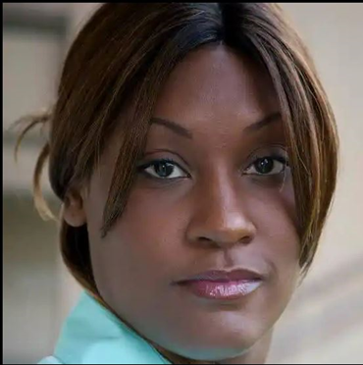 **Salena R. Mabins**

**MODEL/ACTOR**

**WORK EXPERIENCE**

I am “Salena Mabins”, an aspiring model with a unique flare and diverse skill set. I have in-studio and location experience working along side a creative team.

**CONTACT**

1 (313) 231-9173 Studio 1 2023

[info@salenamabins.com](mailto:info@salenamabins.com) Discovery Spotlight 2023

<http://salenamabins.com> John Casablanca 2015

Cibolo, TX Antonio Madison 2015

* Modeled in professional photoshoot
* Worked alongside stylist and makeupartist
* Followed direction of the photographer

**SKILLS**

* Team collaboration
* Military
* Singing
* Interpersonal Skills
* Dancing
* Sports
* Motorcycles, horseback riding
* Roller Skating and Ice Skating
* Time Management

**LANGUAGES**

* English

**Training:**

* Photographic workshops with Antonio Madison Atlanta, GA 2015
* Modeling and Acting workshop from John Casablanca Center, Atlanta, GA 2015
* Modeling and Singing workshop from Discovery Spotlight Orlando, FL 2023